A chaotic Christchurch road trip

Featuring Allan, Aidan, Max, Sophie & Ryan

# Act 1: the fateful Murchison trip

“you’ve put off booking flights for months already Allan @@@” -Ryan, probably

Max, Sophie, Allan and Aidan arrive in Christchurch on Christmas day with 2 weeks to kill and no plans. We see a solidly mediocre window and settle on attempting to climb Murchison. This is a bit of a dubious plan. We have only crampons, axes and helmets, and everyone but Max is fresh out of basic snow. Nonetheless, the climb NZ page describes it as a grade 1 scramble and so we head off into the unknown.

The Waimakariri valley is a 15km river bash which you have to do in order to get anywhere cool in Arthur’s pass. It’s a scrambly mess of eroding choss, potentially committing river crossings and ominous mountains. We arrived there towards the end of a storm at 3pm, and there was a fog and some light rain hanging over the valley. The peaks, when they were visible, were snowcapped and misty.

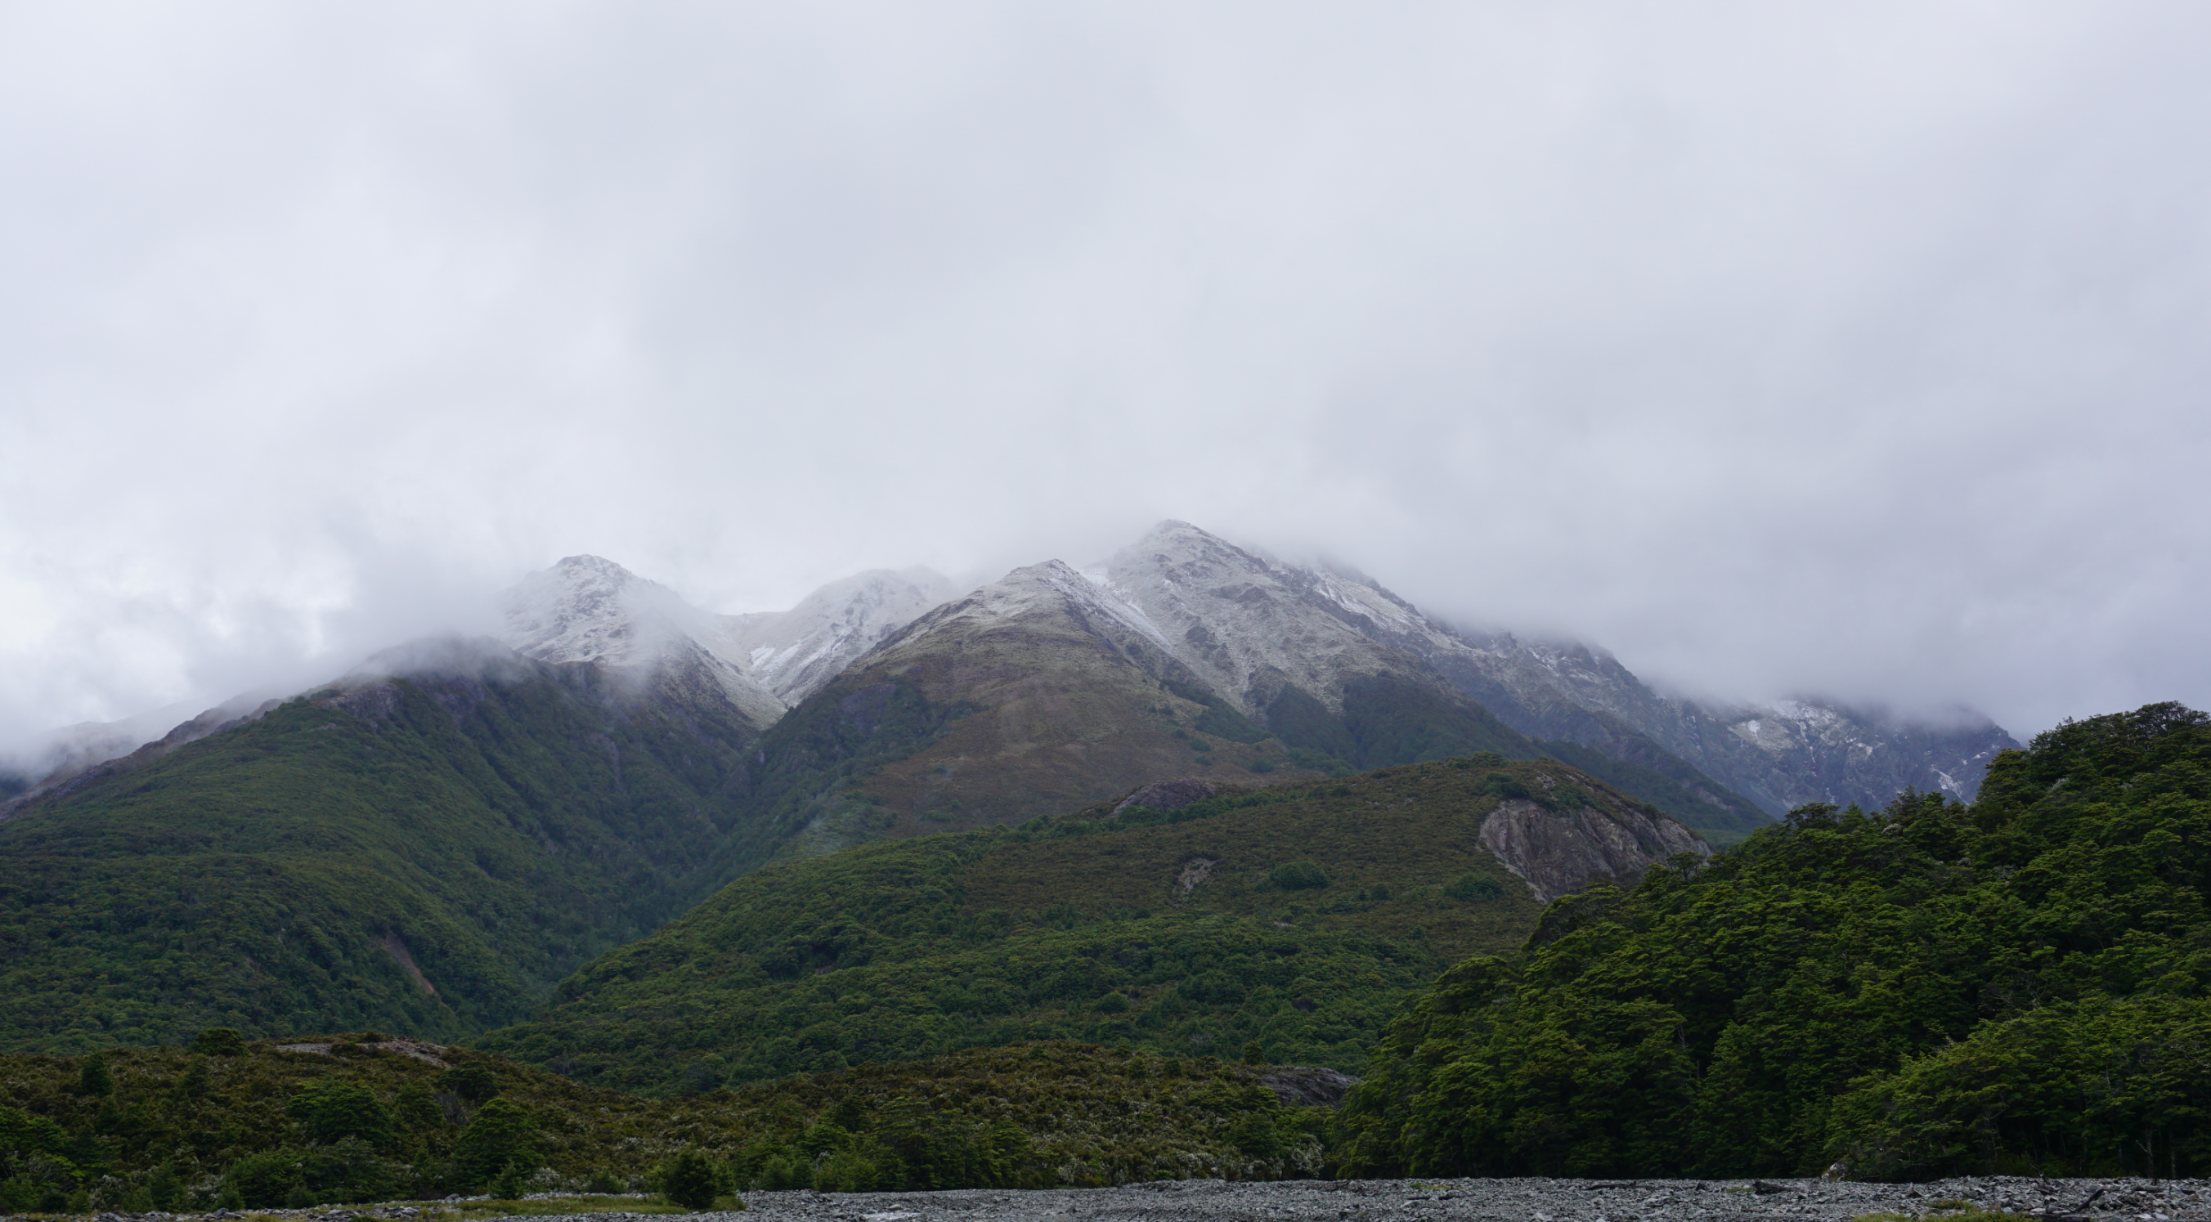

This took us about 6 hours, and we were at Carrington hut as night fell. Sophie found she was surprisingly cold while wearing about 4 layers and made her best attempt to light a fire. Everything was a bit damp, so this mostly served to smoke up the hut, bothering the other residents. Eventually we admitted defeat and retreated to our bunks to watch movies.

Movie viewing on tramps is incredibly underrated. You can download movies to your phone using Netflix or Disney+ and huddle up with your friends for a nice little cinema experience at the end of a long day. If it’s a reasonably dark, quiet space you really forget you’re looking at a phone screen. We had all of The Mandalorian downloaded, and baby Yoda is AMAZING.

There is one catch where you wake up the next day late.

## Max’s diary for day 2

* 6:30 AM – wake up
* 7:30 AM – actually wake up
* 8:00 breakfast and pack
* 9:00 put shoes on. Notice Allan is in his sleeping bag
* 9:01 take shoes back off
* 9:10 sunbathe outside while waiting
* 9:30 Allan decides he needs coffee to go with his breakfast
* 10:00 Remember to sweep hut and do intentions
* 10:30 Off we go!

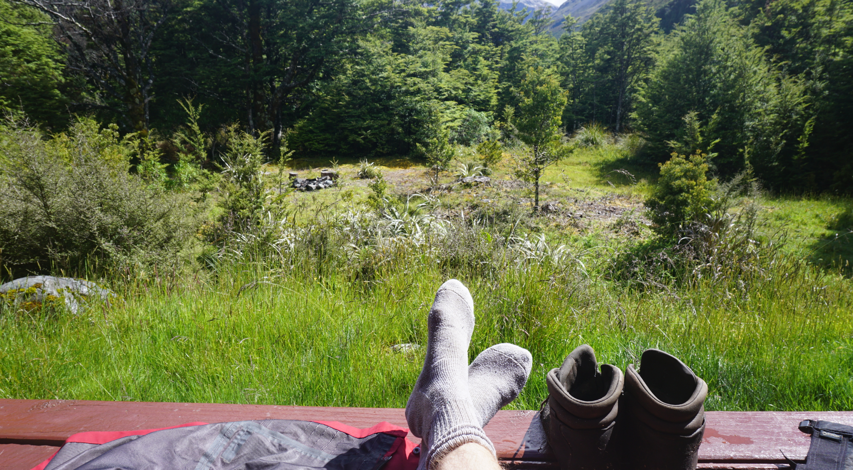

It was a hot day. We gave Allan a lot of shit.

We were headed to Barker hut. This is a Canterbury Mountaineering club hut which they’ve put quite a bit of elbow grease into. It has nice squishy mattresses instead of sad DOC ones, a solar panel, LED lights and a USB charging port. Life was good.

When you plan an objective with snow involved, you do something called an ‘Alpine start’ where you leave early to reduce the likelihood of snow melting and causing avalanches while you’re there. In reality this means you start at some ungodly hour, in stark contrast to the previous day. I distinctly remember putting on my fleece, my puffer jacket and my Hard shells to go outside and check the weather at 5am and immediately shivering as I opened the door. It was brutal. However, it was also bluebird and so we went.

Sophie had some knee problems from the way up to the hut so she stayed with Allan at the hut, and they lived their best life watching pitch perfect. Aidan and Max made their way up the mountain.

To approach Murchison you typically go up the White glacier. This should be an easy gradual glacier traverse with not much technicality. However, in recent years the snowmelt has left a massive step at the bottom of the glacier where you have to traverse to the right and pass a rather thin, exposed rocky ramp to reach the glacier proper.

At the top of the glacier Murchison is a short rocky scramble away. This rock is constantly coming apart as you climb it; nothing is particularly secure and it’s quite exposed. Still, it was a reasonably short, inclined slope; what could go wrong?

## Things go very wrong

After about 30 metres, Max got sketched out and decided to turn around. Aidan was feeling comfortable, so he continued up. Max carefully downclimbed, and while he was putting his crampons on he heard Aidan scream and saw a few rocks skip down the slope. Things then went very quiet.

Aidan had in fact fallen during the downclimb, which is notably harder to do than the ascent in many climbs. He had fell all the way down the rocks onto the glacier where he was finally caught by a patch of powder snow. The trip goes from a fun tramping trip to a rescue operation.

When Max reached Aidan, he was alive with several deep gouges in his arms and legs, and unable to remember what had just happened. Max set the PLB off and patched the injuries with his first aid kit. We got flown out and Aidan turned out to have a few minor breaks in his spine. It took a month or so to recover.